Undergraduate Final Year Project Proposal

Automation testing framework implementation in real project

Nguyen Thanh Tung

Computer science

001245270

Overview
In recent years, aside from the progress and development of software engineering, software testing, or automation testing, has risen to the top of the work career ladder. I spent the last year as an intern at Harvey Nash, a pioneer in professional recruitment and an IT website. And they want me and other interns/Rookies to learn and develop a multilingual code for an auto testing product for their project and sites such as QA and QC.

Aim
To provide necessary skills sets, basic knowledge about software testing and automation testing for new members to be able to design and implement test scripts:
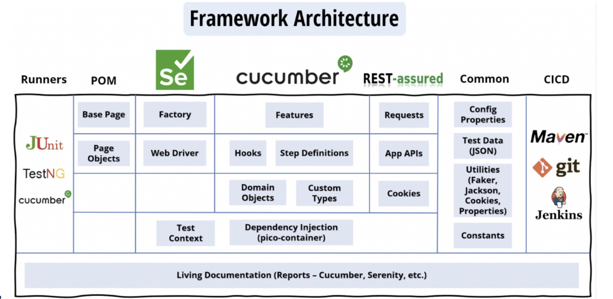
Selenium IDE java
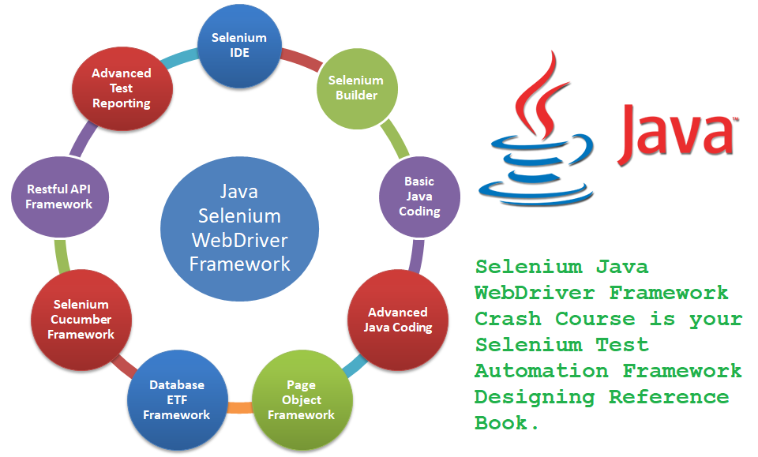
API Testing With Rest Assured – TestNG
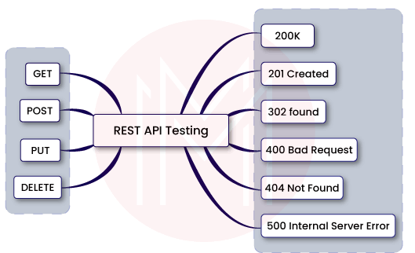
Selenium With Webdriver - TestNG, Cucumber
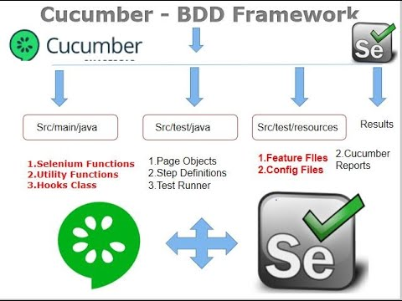
Cypress framework
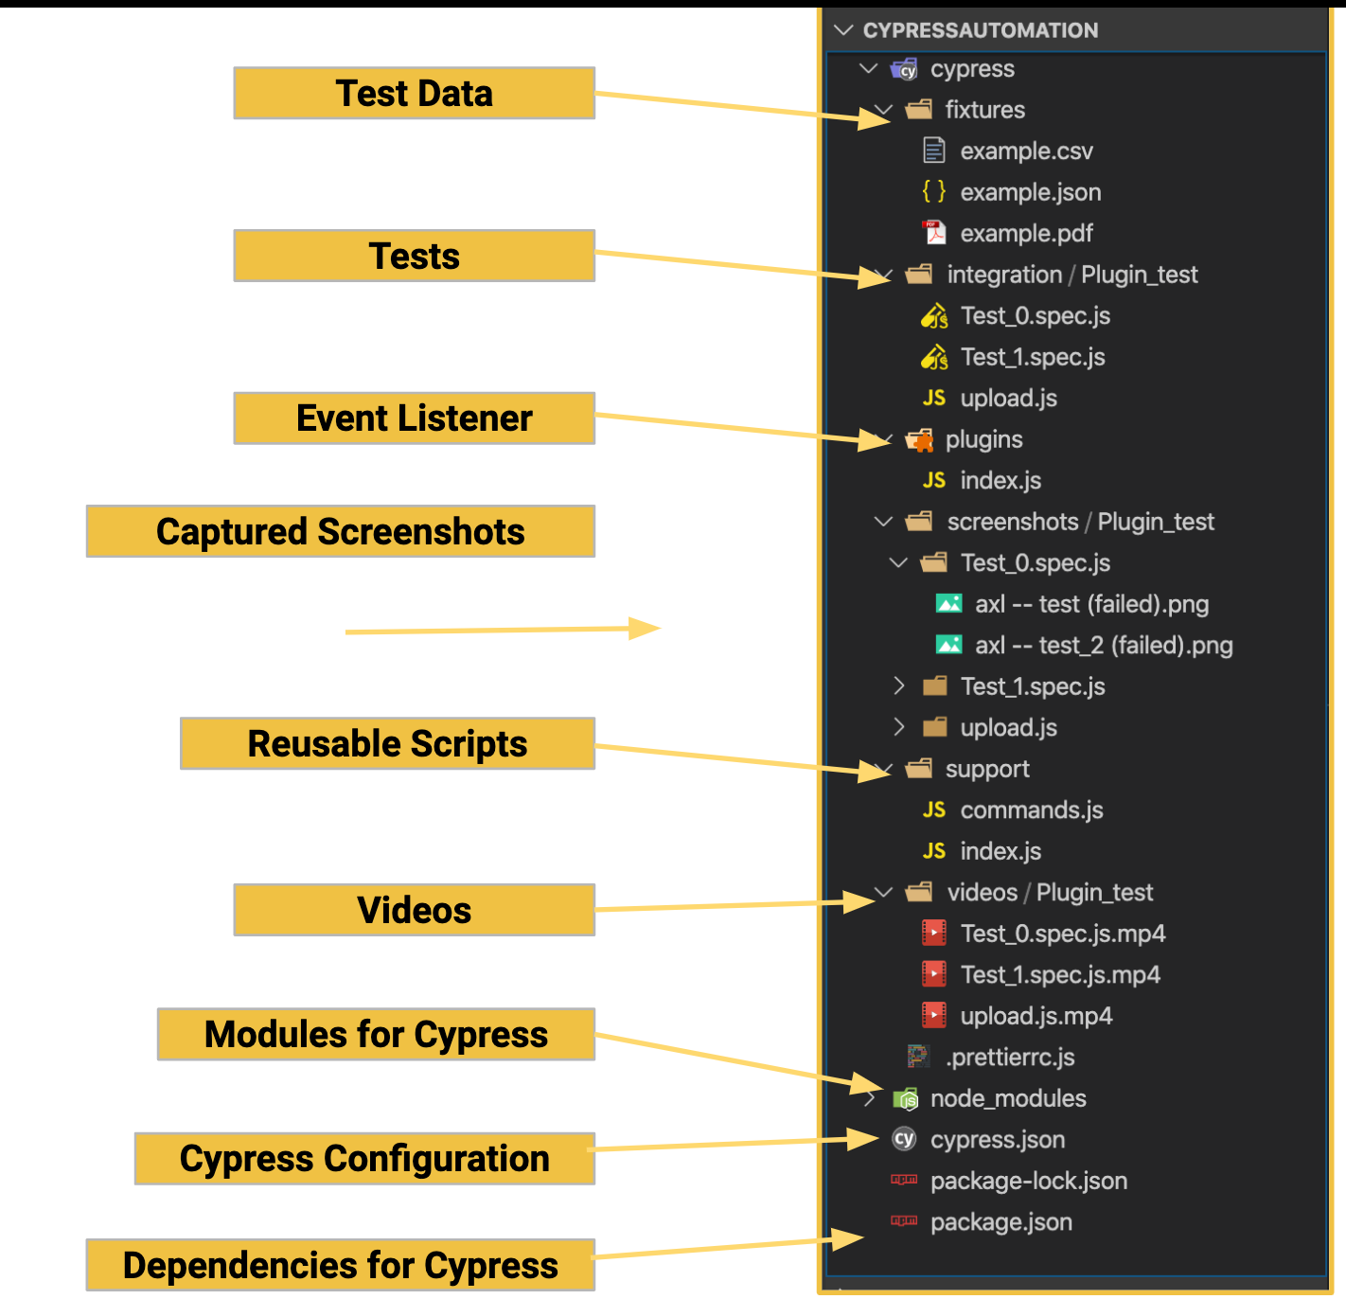

Objectives
- Trainees understand overview of software testing. Trainees know overview of automated testing and UI automated testing. Trainees know how to get good locators. Trainees use basic Git commands in work. Trainees understand Page Object Model. Trainees can use Selenium IDE to record, playback and implement test scripts for UI automated testing. Trainees (Manual Tester) can use Cypress Framework to implement test script for smoke and regression test. Understand and be able to do API testing and UI Testing using Selenium with BDD framework to test a web application in Java language.
LIMITATION
This course is designed to train automation testing in Java language.

Privacy

Wrong access to personal information is a problem that frequently draws your attention to the term "privacy." This section examines privacy from the perspectives of data aggregation, location privacy, public information, and Internet technologies.

Data fusion
Unauthorized access to information might be considered a violation of privacy. As environmental databases grow, in complexity, and connection, software initiatives that combine data or knowledge sources must examine the data's ethical implications. Identify and discuss any legal, social, ethical, or professional difficulties or concerns that may arise because of this proposed initiative.

Planning (see appendix A)
The project will be developed agile SDLC because agile is an environment for development, especially with projects that are not well-planned.

Appendix A - Schedule of Work
SPRINT | TASKS | DURATION |  |  | START | STORY POINT
SPRINT 1 | Learning how to use GitLab and Microsoft Azure |  | 1 week |  | June 1st | 10
 | - What is GIT? |  |  |  |  | 5
 | - Why GIT? |  |  |  |  | 4
 | - GIT basic |  |  |  |  | 6
 | - Azure Microsoft CI CD |  |  |  |  | 2
SPRINT 2 | What is UI automation? Trainees understand the basic concept of automation, the benefit of automation testing and automation testing layer |  | 2 week |  | June 8th | 10
 | - What is UI automation? |  |  |  |  | 5
 | - Automation vs Manual |  |  |  |  | 4
 | - Automation testing layers |  |  |  |  | 6
 | - Common automation frameworks |  |  |  |  | 2
 | - Automation tools |  |  |  |  | 10
SPRINT 3 | Selenium IDE how to use Selenium IDE to record, playback and custom test scripts |  | 2 week |  |  | 10
 | - Test Automation Tools/Frameworks? |  |  |  |  | 5
 | - Common UI testing tools |  |  |  |  | 4
 | - Headless/Headed Browser |  |  |  |  | 6
 | - Mobile Automation Approaches |  |  |  |  | 2
 | - Locator Strategy |  |  |  |  | 10
 | - Distributed Testing  - Visual Validation |  |  |  |  | 5
SPRINT 4 | Selenium Java with TestNG Trainees can use Selenium WebDriver to implement test scripts for functional testing. |  | 2 week |  |  | 10
 | - What is Selenium IDE? |  |  |  |  | 5
 | - Features of Selenium IDE |  |  |  |  | 4
 | - Using Selenium IDE |  |  |  |  | 6
SPRINT 5 | Selenium Java with TestNG Trainees can use Selenium WebDriver to implement test scripts for functional testing. |  | 2 week |  |  | 10
 | - Create Maven project |  |  |  |  | 5
 | - Add dependencies library to project |  |  |  |  | 4
 | - Create project structure? |  |  |  |  | 6
 | - Create System Configuration |  |  |  |  | 2
 | - Create page objects classes |  |  |  |  | 10
 | - Create test classes |  |  |  |  | 5
SPRINT 6 | Page Object Model |  | 2 week |  |  | 10
 | - What is POM? |  |  |  |  | 5
 | - Why to use POM? |  |  |  |  | 4
 | - How to implement POM? |  |  |  |  | 6
 | - POM Structure |  |  |  |  | 2
 |  |  |  |  |  | 10
SPRINT 7 | API Testing with Rest Assured Trainees understand overview of API testing and how to do API test |  | 2 week |  |  | 10
 | - Create Gest project |  |  |  |  | 5
 | - Create project structure? |  |  |  |  | 4
 | - Create System Configuration |  |  |  |  | 6
 | - Create page objects classes |  |  |  |  | 2
 | - Create test classes |  |  |  |  | 10
SPRINT 8 | Selenium with Cucumber Trainees know BDD and how to apply it into UI Testing |  | 2 week |  |  | 10
 | - Create Cucumber project |  |  |  |  | 5
 | - Create project structure? |  |  |  |  | 4
 | - Create System Configuration |  |  |  |  | 6
 | - Create page objects classes |  |  |  |  | 2
 | - Create test classes |  |  |  |  | 10
 |  |  |  |  |  | 5
SPRINT 9 | Cypress Trainees understand Cypress and apply it into UI functional testing |  | 2 week
 | - Cypress Overview
 | - Cypress Basic
 | - Cypress Advance
- Cypress With Cucumber
- Create project structure?
 | - Create System Configuration
 | - Create page objects classes
 | - Create test classes

